Applied Physics Lab (LAB-105) Semester: Fall 2023
Lab No. 8 (Bipolar Junction Transistor) Max Marks: 10
Date: Week 8
Experiment No. 8
To study the operation of a Bipolar Junction Transistor (BJT) as a switch.
Equipment
Trainer Board
Lab Power Supply
Digital Multimeter (x 2)
Transistor (NPN) 2N3904
Resistors 2.2 K Ohm and 7.5 K Ohm
Theory
The N-P-N transistor (2N 3904) is connected in Common Emitter Configuration, i.e. Emitter is common to the input and output circuits. The input circuit is Base-Emitter and the output circuit is Collector-Emitter. In this experiment the input voltage (V_{BE}) is changed and effect on output voltage (V_{CE}) is observed. The transistor will move from Cut-off state (No current in Output circuit) to Saturation state (Maximum current in Output circuit). A small change in V_{BE (}and I_{B)} results in corresponding large change in V_{CE (}and I_{C)}. This is called Transistor Action.
Procedure
- Mount the transistor on the breadboard after checking its pins (Emitter, Base, Collector) and connect the circuit as shown in the diagram. Vary V_{BB} from the Variable Power supply.
- Note down the readings of V_{BE} and V_{CE}, and calculate I_{B} and I_{C}.
- Mention if transistor is in Cut-off or Saturation state (in Remarks Column).
Circuit and Readings (on Graph Paper)

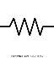
R_{C} = 2.2K

I_{C}
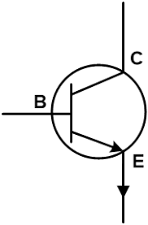


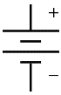
R_{B} = 7.5K
V_{CC} = 5V


V_{BB}
(variable)

Sr. No. | V_{BE} (volts) | V_{CE}  (volts) | I_{B} (mA)  Calculate using Kirchhoff Law | I_{C} (mA)  Calculate using Kirchhoff Law | Remarks  Cut-off or Saturation
1
2

